**6CLP Assignment – Report Template**

|  |  |
| --- | --- |
| Student ID | Name |
| 001077495 | Pisuth Chainarong |

**Gather and Document Requirements**

|  |  |
| --- | --- |
| **Considerations** | **Response** |
| **1.1** Cloud solution vs private ISP hosting – Which Option and Why | Cloud solution –  Cost wise, using cloud hosting is cheaper than private ISP hosting. |
| **1.2** If it is a cloud service, which one – AWS, Google App Engine or Azure? (justify your choice) | Azure-  Microsoft Azure is better supported C# .NET applications and our team has experience on Azure |
| **1.3** Implementation of Core Services- choices are ASP.NET Web Service, MVC, WCF service or REST? (Justify your choice) | WCF Service-  WCF can be consumed by different kinds of client such as android and iOS for future business expansion.  And Our team has a lot of WCF experience. |
| **1.5** Database deployment options- current legacy system or deployed as a cloud-based database (Think scalability and Compatibility) | Cloud-based database-  Compatibility – deploying database in the cloud is a current trend and will have more capability than the legacy database  Scalability – If the database exists on the same machine as client then there is only limited service can be provided. Therefore, putting in the cloud will serve larger volume of request |

**Use Case Model (Add your model here)**

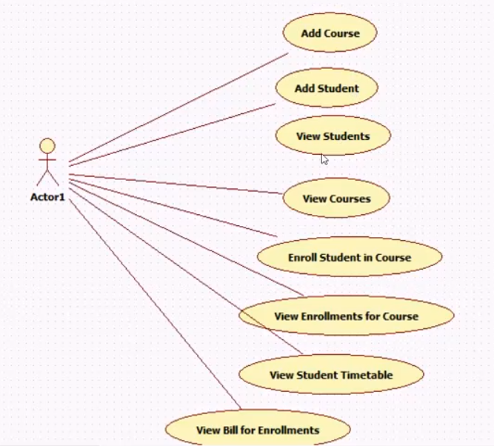

**Use Case Priority List**

|  |  |  |
| --- | --- | --- |
| **Use Case** | **Priority** | **Justification** |
| Add course | 1 | Cannot view course or further actions if there is no course within the database |
| Add student | 1 | Cannot view student or further actions if there is no student in the database |
| Enrol Student in Course | 2 | Enrolment is a primary function for this system and for associating students and courses. |
| View Students | 3 | For checking if add student function works. |
| View Courses | 3 | For checking if add course function works. |
| View Enrolments for course | 4 | The admin can track how many students have enrolled in a particular course |
| View Student Timetable | 5 | For students to view their timetable before issuing bills |
| View Bill for Enrolments | 6 | After the enrolment is finished, the system should be able to issue bills for students |

**Glossary (Define Application Terms here)**

|  |  |
| --- | --- |
| **Term/Phrase** | **Definition** |
| Student | A person that is enrolled in one or more courses |
| Lecturer | A person that teaches at one or more courses |
| Admin | A person that maintains the students, courses, enrolments, and billings. The user of this application. |
| Course | A subject that is available to be enrolled |
| Course Offering | A course that is offered at particular time, at particular date, in particular classroom and by particular lecturer |
| Enrolment | Registration of a student to take apart to a specific Course Offering |
| Billing | The total cost of the courses which a student is enrolled in. |

**Implementation Mechanisms**

|  |  |
| --- | --- |
| **Mechanism** | **Description** |
| Security | Security is out of scope |
| Transaction Processing | Executing the transactions sequentially in any order (xml serialization by WCF) |
| Error Handling | C# Exception Objects |
| Multiple Clients | The implementation of the WCF service can be consumed by multiple clients. |
| Scalability | By hosting the database on the cloud, the system will provide higher scalability |
| Concurrency | Multiple users using the application at the same time. |
| Persistency | By using entity framework, the system will ensure the persistency |

**Development environment and tools required**

* **Multiple web browsers**
* **Microsoft Azure account and portal**
* **Visual Studio 2015 with Azure SDK**

**UML Model - Design Classes and relationship**

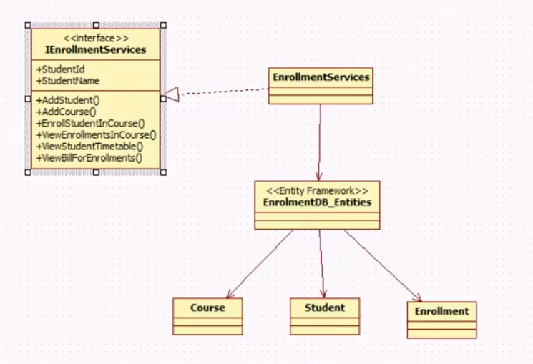

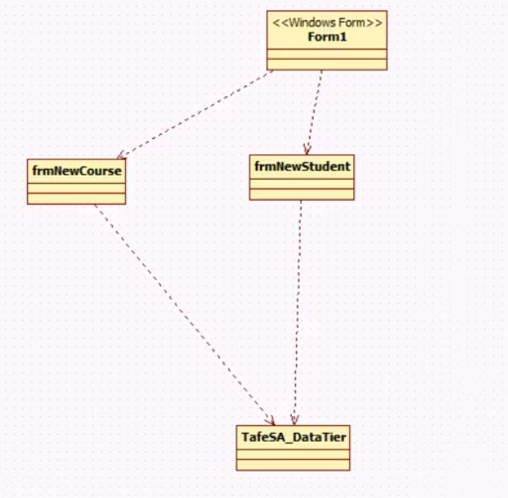

**A UML component model**

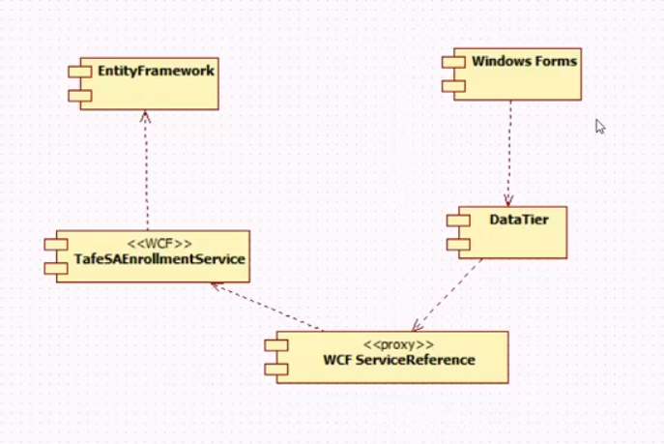

**Test Plan**

**Testing Service Before Publishing**

* **insertStudent(string:id, string:name, DateTime:datetime)->return int**
* expected return 1
* actual return 1

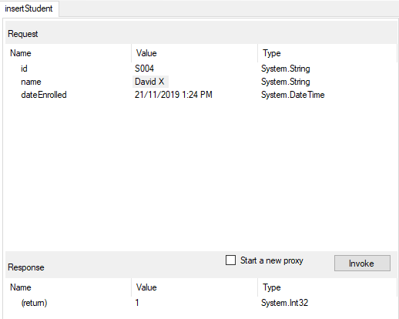

* **viewStudents()->return List<Student>**
* expected the previous insert to be found (David X)
* actual: as expected

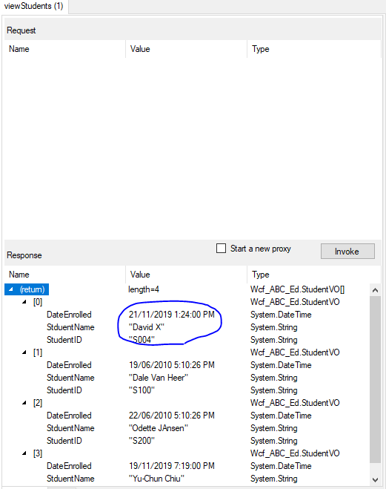

* **insertCourse(string:id, string:name,decimal:cost)->return int**
* expect return 1
* actual return 1

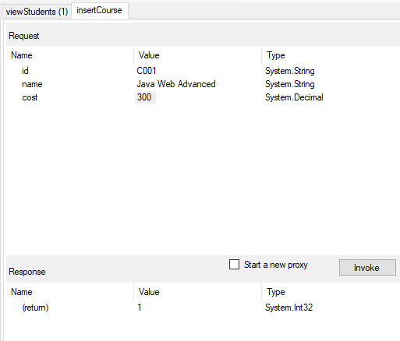

* **viewCourses()->return List<Courses>**
* expected the previous insert to be found (C001)
* actual: as expected

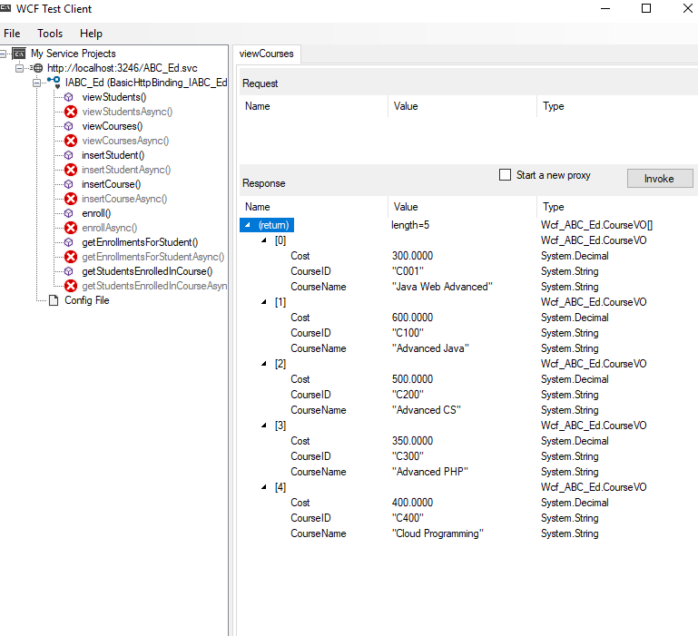

* **enrol(string:studentID,string:courseID)->return int**
* expected return 1
* actual return 1

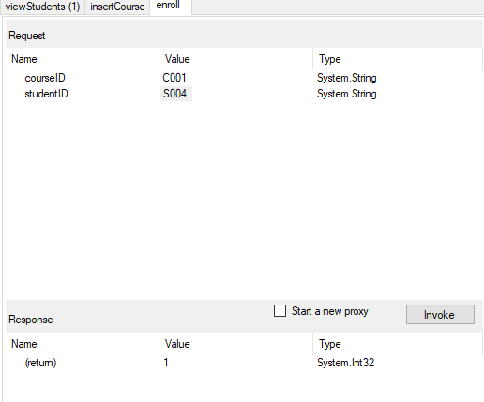

* **getEnrollmentsForSdtudent(string: studentID) -> return List<Enrollment>**
* expected the previous insert to be found (C001)
* actual: as expected

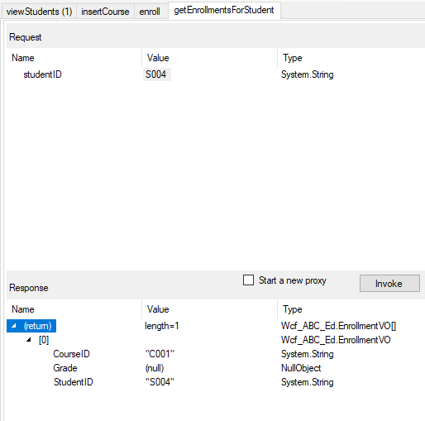

* **getStudentsEnrolledInCourse(string:courseID)->return List<Student>**
* expected all students who is (are) enrolled in C100 – S100 and S300
* actual: S100 and S300

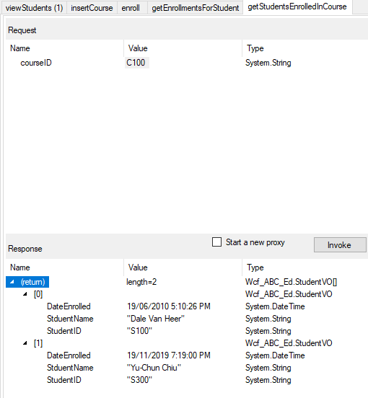

**Testing Service After Publishing**

* **insertStudent()**

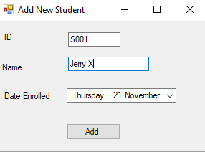

* **viewStudents()**

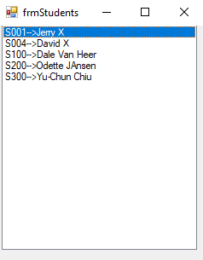

* **insertCourse()**

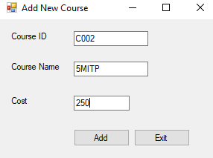

* **viewCourses()**

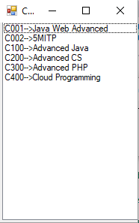

* **enroll()**

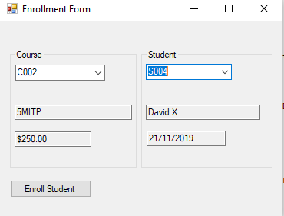

* **getEnrollmentsForSdtudent()**

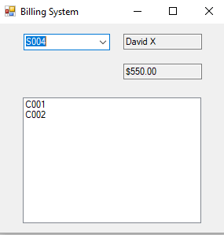

* **getStudentsEnrolledInCourse()**

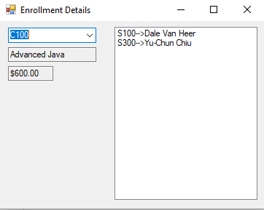

**Steps - Deploying /Publishing your services**

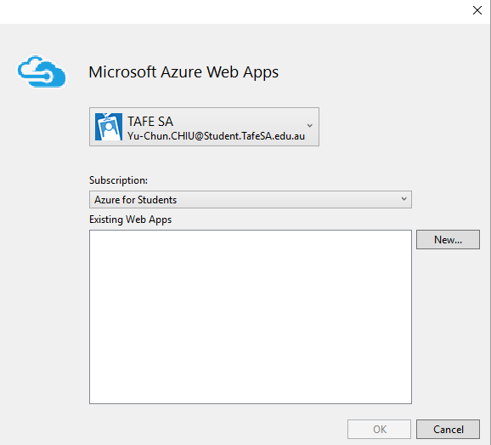

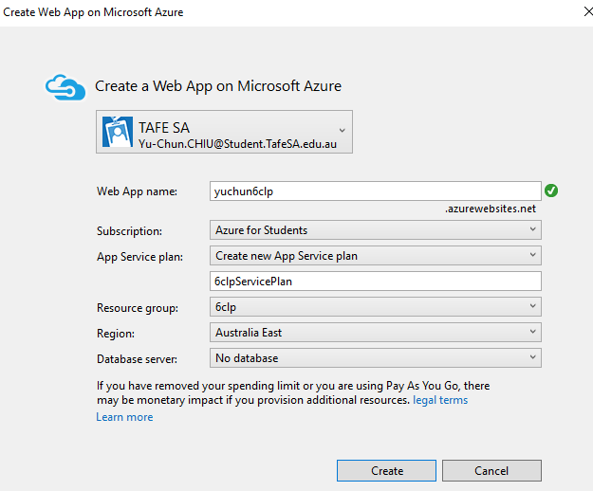

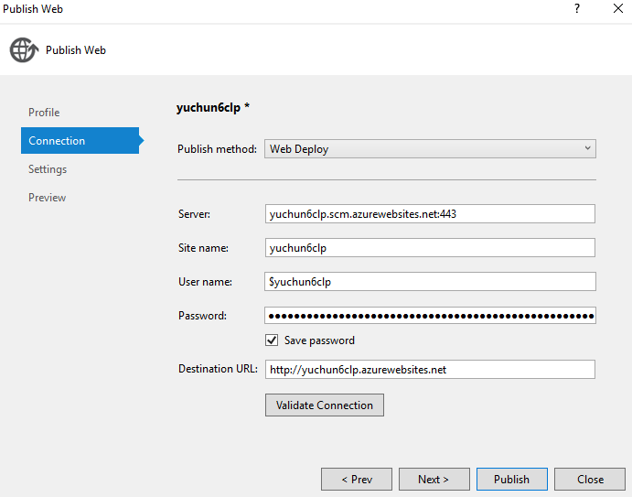

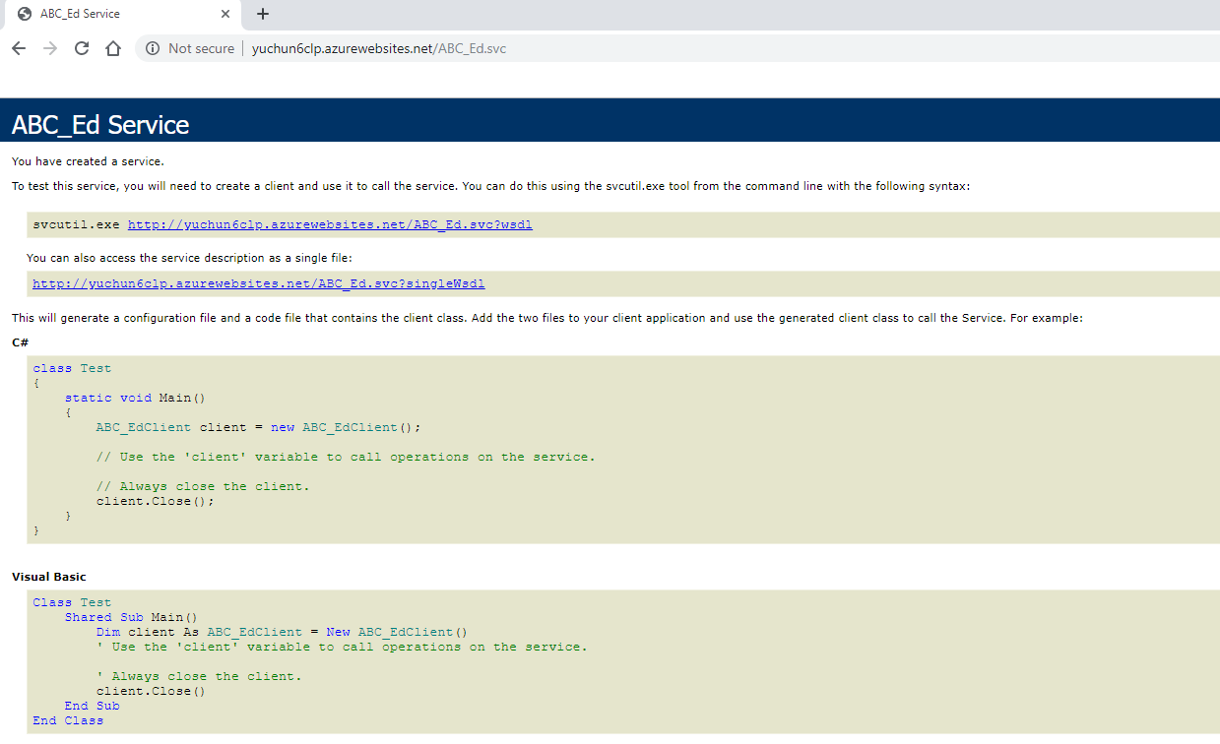

|  |  |
| --- | --- |
| **URL** | <http://yuchun6clp.azurewebsites.net/ABC_Ed.svc> |

**Further Research**

**-Big Data Considerations (500 words)**

Big data is referring to information that can be utilized by companies through data analysis, which diverse in nature and it always grows in an increasing rate. Therefore, the volume or amount of the information, the velocity or speed of the data being created and collected, and the variety or scope of the data that need to be covered are the main points that need to be encompassed in big data analysis.

Big data itself can be categorized as structured and unstructured. Structured data normally come from the company itself, where the information has been saved and managed into the company databases or spreadsheets. This makes the formatting of the data to suits the information required by the company a lot easier. The nature of the data usually will be in a numeric type. Meanwhile, unstructured data is an information that doesn’t have a predefined structure or format and less quantifiable than structured data. It includes data gathered from social media sources, which help companies gather information on customer needs.

Big data can be gathered through different kinds of channels, some of the examples: online or offline questionnaires, comments on company websites or social medias, inputs from sensors or other smart devices that allows data to be collected. Gathered data is stored in computer databases and is analyzed by using specialized software that able to handle large volume and complex data. Because of the complexity of the specialized software needed to analyses the data, there are lots of companies that specialized just to manage big data in Software as a Service (SaaS) company type.

Data analysis of big data can be done in-house or outsourcing it into third parties who focus on handling and processing big data into a clearer and concise information. Information produced from the data analysis then can be used as an assessment of situations faced by a company to help in taking actionable decisions. This is because the larger the information gathered and analyzed the more complete the answers for handling a certain situation.

Although nearly every department in a company can utilize findings from big data analysis, there are some problems arise from big data. Companies must be able to handle larger volumes of data, while determining which data represents signals and not just noises. Determining what makes the data relevant is a key factor in data analysis. Also unstructured data which most likely the main source of big data has to be handled by special techniques before it can be useful.

Few cases where big data can help addressing future business activities of TAFE:

• Build predictive models for new courses/services by classifying key attributes of past and currents courses/services by modelling the relationship of those key attributes with successful offered courses/services.

• Analyze factors that can predict mechanical or hardware failures of TAFE system to identify potential issues before the problems happen, therefore TAFE can deploy maintenance more effective and efficient.

• Enables TAFE to gather data from students through social media, web visits, call logs, and other sources to improve TAFE student's interaction experience and maximize values delivered.

• Help innovating the TAFE executives to use information gathered from big data to improve decisions about financial and planning considerations.

**-Xml Serialization vs. JSON Serialization**

Xml – is a disciplined language, XML configuration files are a recognized standard in the .NET world. XML can contain binary data while JSON is only used to send plain text data.

JSON – is developed based on JavaScript. It is a language-independent standard; therefore, it can be used anywhere. And now JSON is widely used crossed different platform. JSON is usually more concise than XML, so it will generally perform better over a network

Personally, I prefer Xml Serialization over JSON because I mostly work in .NET Framework. However, JSON Serialization is worth to take a look at since soon enough we will see more service that will inject JSON data in their architecture.

**-ASP.NET MVC vs. WCF Services**

MVC can only serve web clients, however, the requirement is the service should be exposed by different client not just web client. Therefore, we choose to go with WCF service because the required service needs to be consumed by different clients including web clients and non-web clients.

**-Windows Forms vs. ASP.NET Html Views**

Currently the client is using Windows Forms and they do not want to change. However, the move towards more html supported by ASP.NET might be something that needs to be considered in the foreseeable future because ASP.NET Html views can allow multiple users to access the service.